b.WAN Authentication Protocols: Authentication is Needed in WAN, WAN Authentication Protocols: HDLC, PPP Authentication (PAP, CHAP, MS-CHAP).
Tasks
1.Draw a simple network diagram showing two routers connected over a WAN link and label where authentication is needed to prevent unauthorized access.
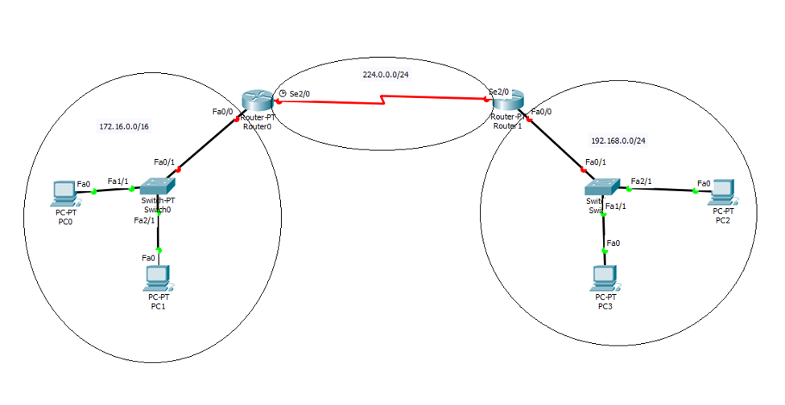
Network Structure
Left LAN (172.16.0.0/16)
The left side of the network contains:
- PC0
- PC1
- Switch0
- Router0
PC0 and PC1 are connected to Switch0, which is connected to Router0 through the FastEthernet interface. All devices belong to the 172.16.0.0/16 network. Router0 acts as the default gateway for this LAN and forwards traffic destined for other networks.
Right LAN (192.168.0.0/24)
The right side contains:
- PC2
- PC3
- Switch1
- Router1
PC2 and PC3 are connected to Switch1, which is connected to Router1. These devices belong to the 192.168.0.0/24 network. Router1 serves as the default gateway for this LAN.
WAN Connection (224.0.0.0/24)
Router0 and Router1 are connected through their Serial 2/0 (Se2/0) interfaces using a WAN link. The WAN network is labeled 224.0.0.0/24. This serial connection allows communication between the two geographically separated LANs.
How Communication Works
Suppose PC0 wants to send data to PC2:
- PC0 checks the destination address and realizes that PC2 is on a different network.
- PC0 sends the packet to its default gateway, Router0.
- Router0 examines its routing table and forwards the packet through the WAN serial link.
- The packet travels across the 224.0.0.0/24 WAN network to Router1.
- Router1 receives the packet and forwards it to Switch1.
- Switch1 delivers the packet to PC2.
The same process occurs when PC2 communicates with PC0.
Purpose of the Switches
The switches provide local connectivity within each LAN:
- Switch0 connects PC0 and PC1 to Router0.
- Switch1 connects PC2 and PC3 to Router1.
They operate at Layer 2 (Data Link Layer) and forward frames based on MAC addresses.
Purpose of the Routers
The routers perform:
- Inter-network communication
- Routing between different IP networks
- WAN connectivity
- Traffic forwarding
Without the routers, devices in the 172.16.0.0/16 network would not be able to communicate with devices in the 192.168.0.0/24 network.
2.Configure a sample HDLC WAN connection between two routers using Packet Tracer or any network simulator, and explain why HDLC does not provide authentication.Hint: Focus on the commands used and what is missing in terms of security.
Router0 Configuration
Router0> enable
Router0# configure terminal

Router0(config)# interface serial 2/0
Router0(config-if)# ip address 224.0.0.1 255.255.255.0
Router0(config-if)# encapsulation hdlc
Router0(config-if)# clock rate 64000
Router0(config-if)# no shutdown
Router1 Configuration
Router1> enable
Router1# configure terminal

Router1(config)# interface serial 2/0
Router1(config-if)# ip address 224.0.0.2 255.255.255.0
Router1(config-if)# encapsulation hdlc
Router1(config-if)# no shutdown
3.Set up a PPP connection between two routers in Packet Tracer and enable PAP (Password Authentication Protocol) authentication. Show the configuration commands and explain what happens if the password is incorrect.
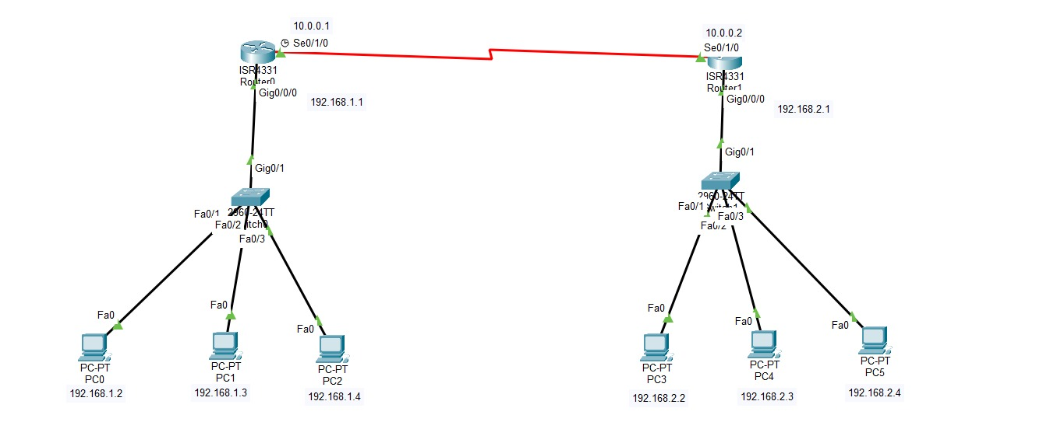
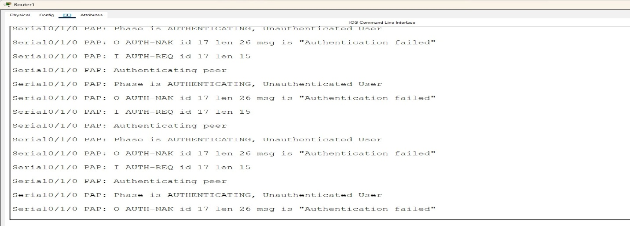
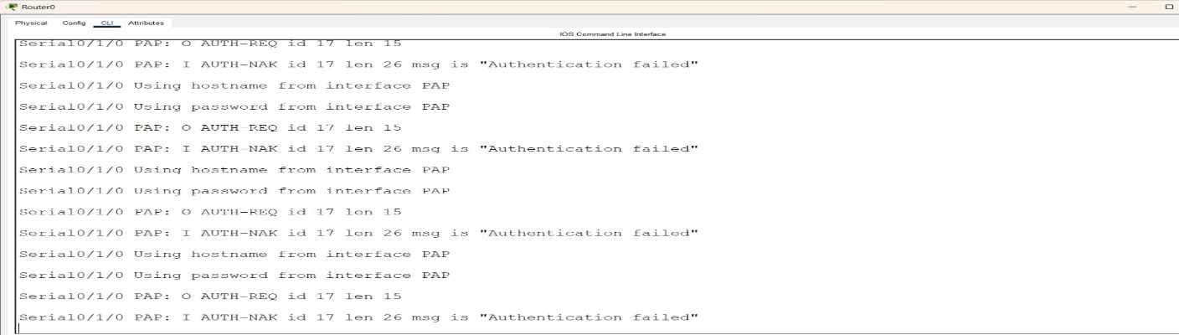

4.Modify your PPP configuration to use CHAP (Challenge Handshake Authentication Protocol) instead of PAP, and describe one key difference in how CHAP improves security over PAP.
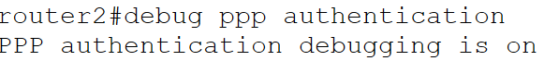


5.Research and list two real-world scenarios (such as public WiFi login or mobile data authentication) where WAN authentication protocols like PAP, CHAP, or MS-CHAP are used, and explain why authentication is critical in each case.
1. Public WiFi Login (Campus, Airport, or Hotel WiFi)
Many public WiFi networks use authentication protocols such as CHAP or MS-CHAP through RADIUS servers to verify users before granting internet access. When a user connects to the WiFi network, they must enter a username and password on a login portal. The authentication server validates the credentials and determines whether access should be allowed.
Why authentication is critical:
- Prevents unauthorized users from accessing the network.
- Protects network resources from misuse.
- Helps track user activity for security and troubleshooting.
- Reduces the risk of cyberattacks on the network.
2. Mobile Data Authentication (Cellular Networks)
Mobile service providers use authentication mechanisms similar to CHAP and MS-CHAP to verify subscribers when they connect to 4G or 5G networks. The mobile device communicates with the carrier's authentication system, which verifies the user's SIM card and subscription details before allowing access to voice and data services.
Why authentication is critical:
- Ensures that only valid subscribers can use the network.
- Prevents fraud and unauthorized use of mobile services.
- Protects customer accounts and billing information.
- Enables accurate usage tracking for billing and service management.

